Have your database selected in the left nav panel. Click “privileges”

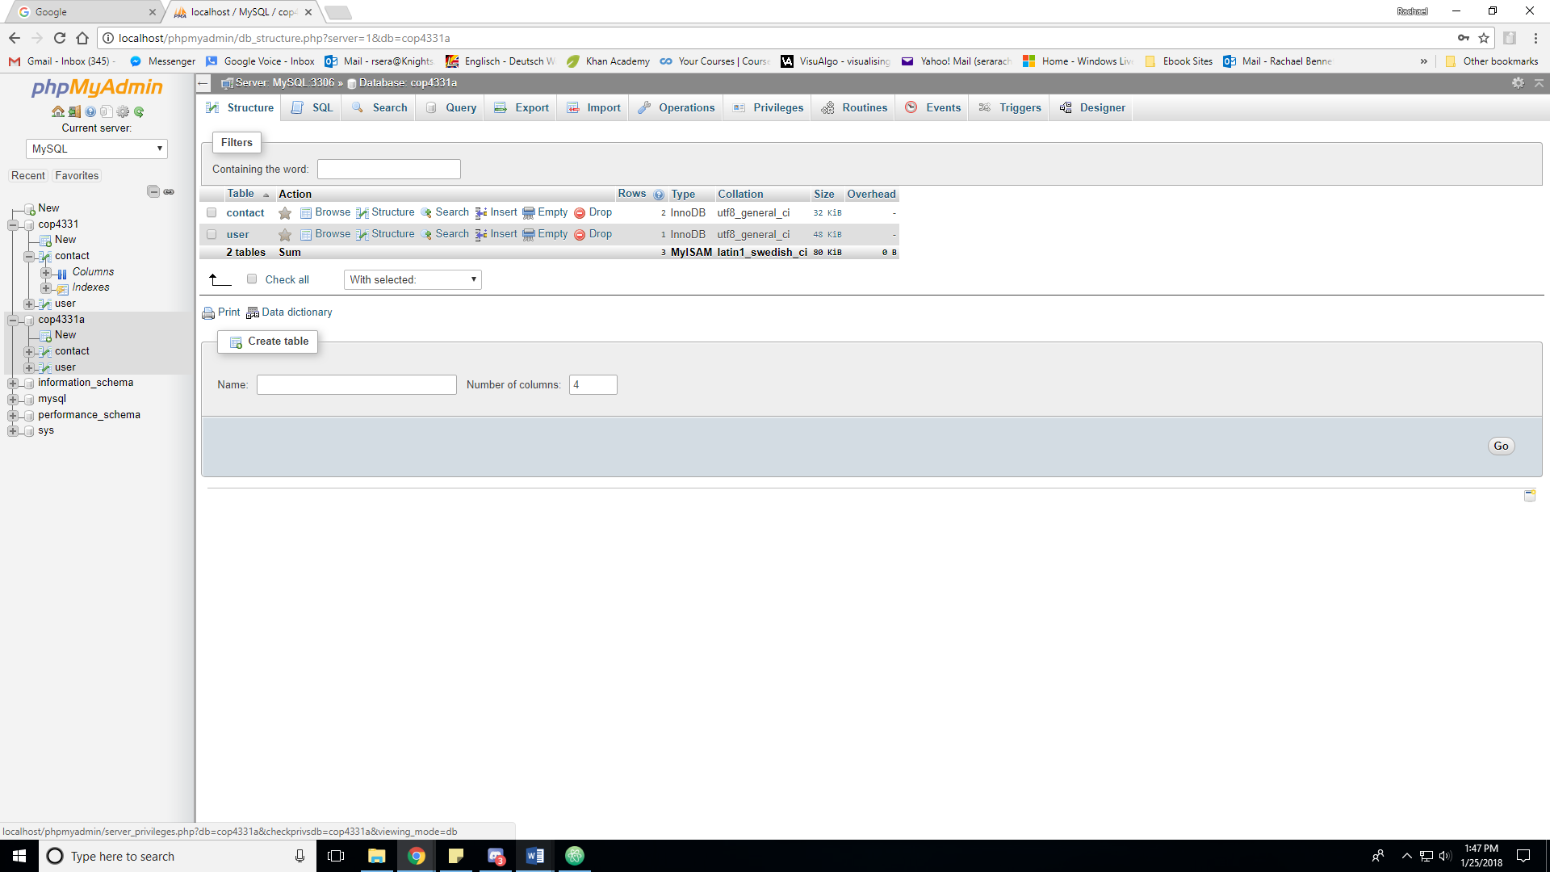

Click “Add user account”

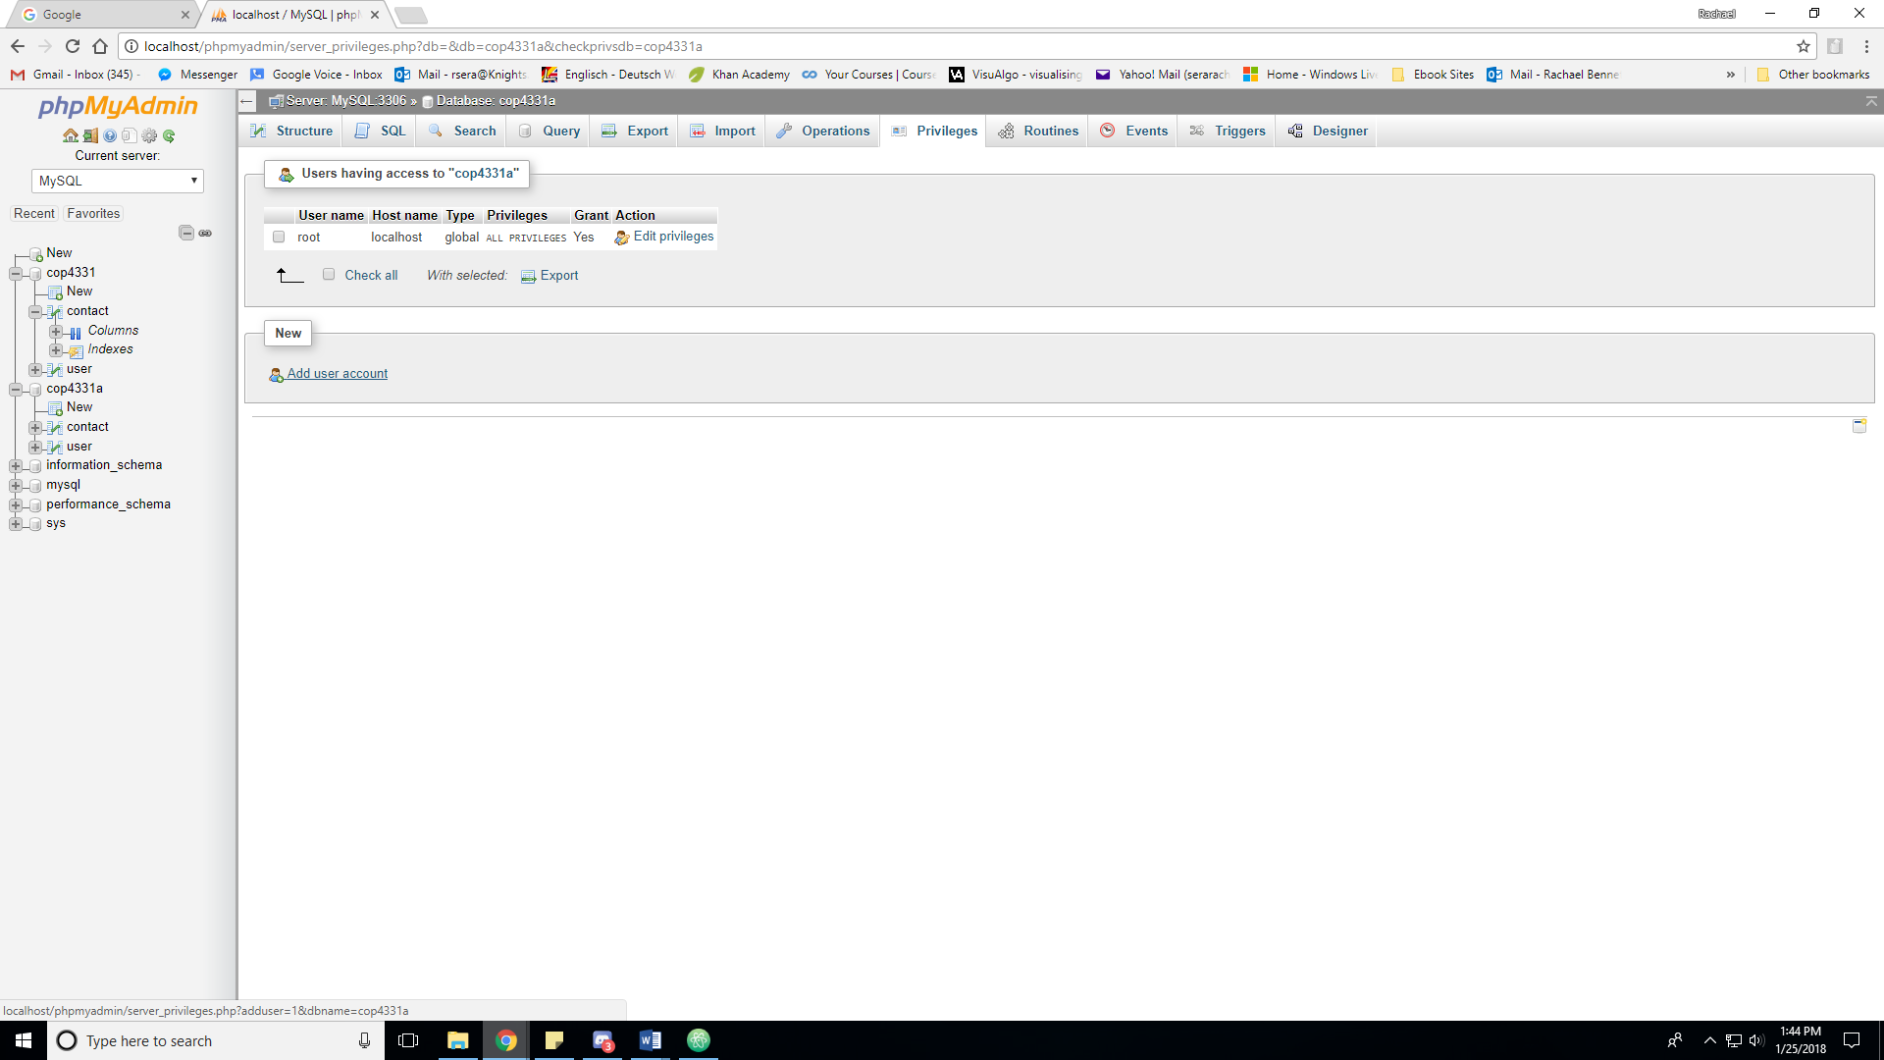

Make the username “SaRcc” and the password “Wash9Lives!” (so it matches what’s in the code) and keep the % in the hostname

Scroll alllll the way to the bottom and click “Go”

